

Python Practical’s

# TASK 3

Smit Joshi | 07-08-2023

View On [**github.com/smit-joshi814**](https://github.com/smit-joshi814/Learning-python/tree/main/collage/Task3)

# Practical 1

Write a program to find whether the given number from user is Positive,

Negative or Zero.

number=int(input("Enter Number "))

if number>0:

    print(f"Number is Positive")

elif number<0:

    print(f"Number is Negative")

else:

    print("Number is Zero")

### Output:

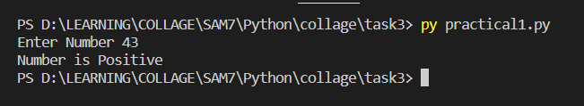

# Practical 2

Write a program to split the input data into rupees and paisa (For eg. INPUT

59.47 as Rs 59 and 47 paisa ).

number=input("Enter Money: ")

money=number.split('.')

print(f"rupees: {money[0]} and paisa: {money[1]}")

### Output:

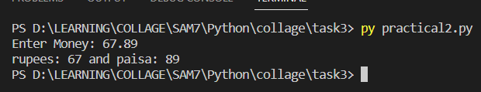

# Practical 3

Write a program to calculate number of seconds given by user into h:m:s.

seconds=int(input("Enter Seconds: "))

minutes=0

hour=0

for i in range(1,seconds):

    if i%60==0:

        minutes+=1

        if minutes>60:

            hour+=1

            minutes=0

seconds%=60

print(f"{hour}:{minutes}:{seconds}")

### Output:

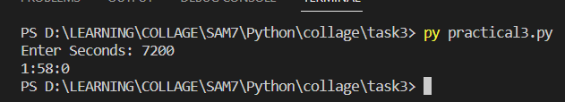

# Practical 4

Write a Python program to count the number of even and odd numbers from a

series 1 to N (N will be entered by user).

N=int(input("Enter N Limit "))

odd=0

even=0

for i in range(1,N+1):

    if i%2==0:

      odd+=1

    else:

       even+=1

print(f"Odd Count:{odd}")

print(f"Even Count {even}")

### Output:

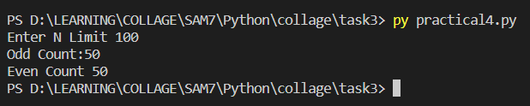

# Practical 5

Write a Python program to Print those numbers which are divisible by 7 and

multiple of 5, between 1500 and 2700 (both included), also print total of such

numbers.

for i in range(1500,2700):

    if i%7==0 and i%5==0:

        print(i,end=" ")

### Output:



# Practical 6

Write a Python program to guess a number between 1 to 10. User is prompted

to enter a guess. If the user guesses wrong then the prompt appears again

until the guess is correct, on successful guess, user will get a “Correct!!!!"

message, and the program will exit.

import random

while True:

    number=int(input("Enter Any Random Number: "))

    computer_guss=random.randrange(1,10)

    if number==computer_guss:

        print("Correct!!!!")

        break

    else:

        print("Computer Guss:",computer_guss)

### Output:

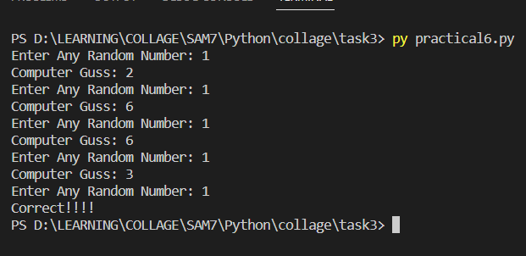

# Practical 7

Write a python program to perform following operations on List and display

the results after each operation:

(i) Create list with elements 57, 89, 78 and 1.

(ii) Insert 50 on third position and 25 on first position.

(iii) Delete second last element of the list.

(iv) Reverse the list

(v) Find maximum and minimum of the list

(vi) Sort the list

# Assuming position=index+1

myList=[57,89,78,1]

print("List: ",myList)

myList.insert(2,50)

print("i.",myList)

myList.insert(0,25)

print("ii.",myList)

myList.pop(-2)

print("iii.",myList)

myList.reverse()

print("iv.",myList)

print("v. Maximum ",max(myList),"Minimum",min(myList))

myList.sort()

print("vi.",myList)

### Output:

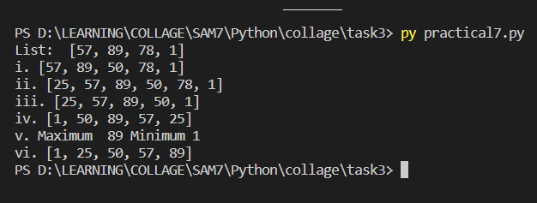

# Practical 8

Write a Python program to to perform following operations on Tuple and

display the results after each operation:

(i) Create tuple with elements 65,12, 78 ,12, 23 and 7

(ii) Display 4th element from starting and 2nd element from last.

(iii) Count the occurence of 12 in the tuple

(iii) Create tuple containing all your subjects

(iv) Find minimum and maximum from both the tuple

myTuple=(65,12,78,12,23,7)

print("i.",myTuple)

print("ii. from startring:",myTuple[3],"from last:",myTuple[-2])

print("iii. occurence:",myTuple.count(12))

subjects=("DAA","NoSQL","Python","OOAD","CCV")

print("iv. Minimum:",min(myTuple),"Maximum:",max(myTuple))

print("iv. Minimum:",min(subjects),"Maximum:",max(subjects))

### Output:

